THE

BUSINESS

STANDARD

Uttara University signs MoU with Wadhwani Foundation
15 September, 2025

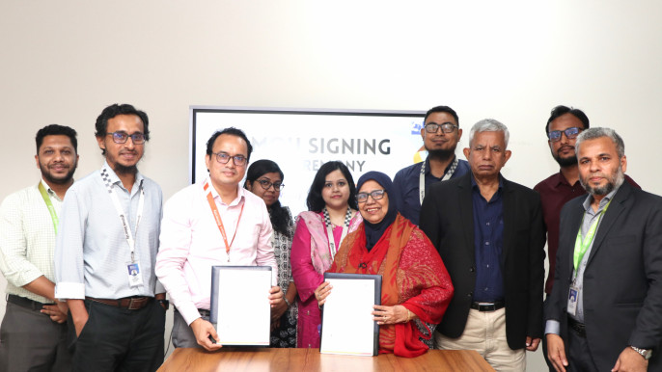
Uttara University has signed a Memorandum of Understanding (MoU) with Wadhwani Foundation to introduce the 21st Century Employability Skills Development Course for outgoing graduates. The agreement marks a strategic step towards enhancing student employability by equipping them with skills that complement the university's curriculum.
The signing ceremony took place at the Uttara University Meeting Room in the presence of senior officials from both institutions. Attending the event from Uttara University were Professor Haspia Bashirullah, Treasurer; Professor Dr Mirza Golam Rabbani, Dean, School of Science and Engineering (SoSE); Professor Dr Md Sultanul Islam, Dean, School of Civil, Environmental and Industrial Engineering (SoCEIE); Dr Ishrat Hossain, Dean, School of Business Administration (SoB); and Acting Registrar Mohammad Ali. From Wadhwani Foundation, Md Omar Faruk, Director, Student Success, Bangladesh, and Md Radowan Islam, Senior Associate, Learner Success, Bangladesh, were also present. The programme was coordinated through the Office of External Affairs, Uttara University.
Wadhwani Foundation, an internationally certified organisation, has been actively working to empower young graduates through philanthropic initiatives. Its programmes focus on career guidance, skill development, internships, scholarships, training, and mentorship—fostering leadership and creating meaningful opportunities for youth to contribute positively to society and the workplace.
Speaking on the occasion, officials of Uttara University emphasized that the collaboration with Wadhwani Foundation represents a significant initiative to prepare students for the demands of today's competitive job market. They noted that the employability course would empower graduates with practical knowledge, problem-solving ability, and workplace adaptability—skills that are vital for thriving in their professional careers.
By introducing this skills development programme, Uttara University aims to bridge the gap between academic learning and industry requirements, ensuring that its graduates are equipped not only with academic excellence but also with the competencies needed to succeed in diverse career paths.

