
04 October, 2025
Is teaching just a job or a noble profession?

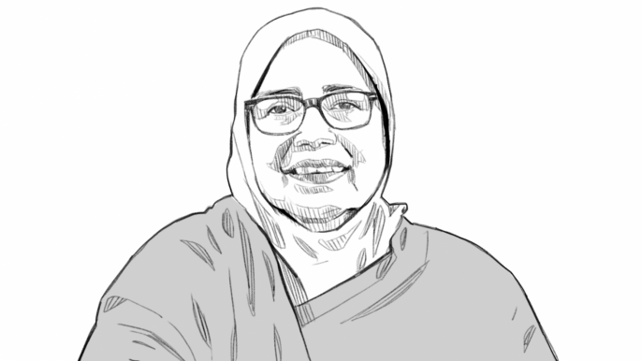
Professor Haspia Bashirullah is the treasurer of Uttara University.
In a world driven by technology and rapid change, teachers are now performing roles not just as educators, but as mentors, dreamers, and builders of society. From shaping character to igniting lifelong curiosity, teaching emerges as a noble calling that leaves a lasting imprint on generations after generation.
A teacher gives far more than what's written in the textbooks and lectures. Through patience, care and vision, they pass on insights, values and knowledge that continue to sustain students for decades after they leave school. The lessons learned from a teacher often become the guiding principles that help a student overcome challenges, pursue goals and dream bigger things.
In many ways, a teacher creates a second home, a nurturing environment where children grow not only in knowledge but also in humanity. From the very first day of school to the farewell, teachers stand beside their students, helping them cross every stage of growth. They celebrate small victories, correct mistakes, and offer encouragement during moments of struggle. Every successful professional, be it a doctor, lawyer, engineer, or artist, carries within them the imprint of a teacher's influence. That is why society owes teachers the highest honor.
There is something unique about the nobility of this profession. A teacher's success is never linked to misfortune. Their growth and recognition come only through the spread of knowledge, prosperity, and goodness. Unlike any other profession, teaching thrives on collective progress. A teacher does not rise alone; they rise with their students. A true teacher's dream is not material wealth, but to see their students standing tall as responsible citizens, creative minds, and compassionate human beings. Their ultimate reward lies in seeing students contribute to society and the nation, leading meaningful and fulfilling lives. In an age where technology often overshadows human values, the role of teachers remains irreplaceable. Machines may provide information, but only a teacher can inspire.
A teacher plants seeds of curiosity, waters them with encouragement, and nurtures them with discipline until they grow into strong trees of knowledge and wisdom. Teaching is not just a profession—it is the backbone of a civilization. A teacher's dream should be to build a better tomorrow for his/her pupils nothing more, nothing less.
Professor Haspia Bashirullah is the treasurer of Uttara University.

